**Iphone X 128GB**

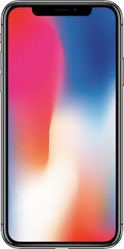

## The main

A type smartphone

Operating system Apple iOS

Operating system version iOS 13

Screen size 5.8"

Screen resolution 1125x2436

RAM 3 GB

Flash memory 128 GB

Integrated camera 12MP + 12MP

Number of main cameras 2

Number of matrix points 12 megapixels

SIM Card Number 1

SIM Card Format nano-sim, eSIM

Maximum video resolution 3840x2160 (60 fps)

## ****CPU****

CPU Apple A11 Bionic

CPU clock speed 2 390 MHz

Number of Cores 6 (2 + 4)

CPU architecture ARMv8-A (2x Monsoon + 4x Mistral)

CPU capacity 64 bits

Process technology 10 nm